**VA EXIT SURVEY**

Thank you very much for taking the time to complete the VA Exit Survey.  Your responses to this survey are voluntary and will remain anonymous.  To protect your anonymity, the data will only be reported when there are 5 or more responses to each question and/or 5 or more responses in each demographic group.  Free text responses will be provided verbatim to facility points of contact.  We expect the survey to take approximately 5-10 minutes to complete.  
  
Concerns such as grievances, patient safety issues, discrimination, harassment, ethical concerns, or other time sensitive issues should be reported directly to responsible parties at your organization to ensure they receive prompt attention.  
  
If you have any difficulty completing the survey, please contact the helpdesk via e-mail at vhahtmsurveyhelpdesk at va.gov.  If you have questions about the survey administration or Directive 5004, please contact vaentranceexitsurvey at va.gov.  
  
  
Thank you for your service to Veterans!

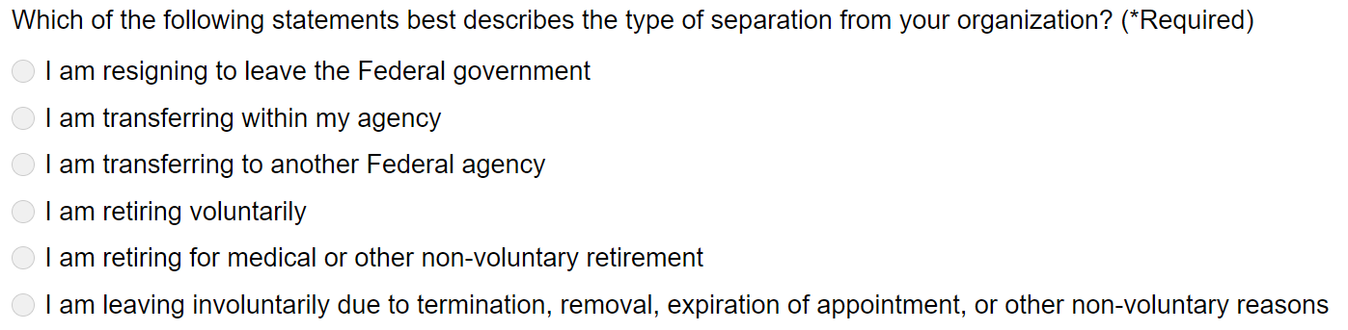

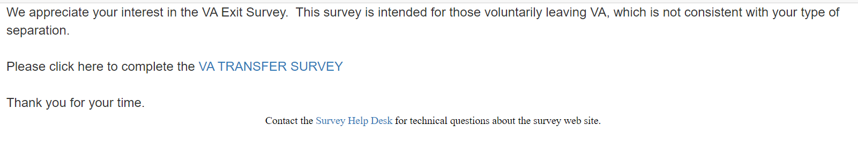

**VA STATION TRANSFER SURVEY**

Thank you very much for taking the time to complete the VA Station Transfer Survey.  Your responses to this survey are voluntary and will remain anonymous.  To protect your anonymity, the data will only be reported when there are 5 or more responses to each question and/or 5 or more responses in each demographic group.  Free text responses will be provided verbatim to facility points of contact.  We expect the survey to take approximately 5-10 minutes to complete.  
  
Concerns such as grievances, patient safety issues, discrimination, harassment, ethical concerns, or other time sensitive issues should be reported directly to responsible parties at your organization to ensure they receive prompt attention.  
  
If you have any difficulty completing the survey, please contact the helpdesk via e-mail at vhahtmsurveyhelpdesk at va.gov.  If you have questions about the survey administration or Directive 5004, please contact vaentranceexitsurvey at va.gov.  
  
  
Thank you for your service to Veterans!

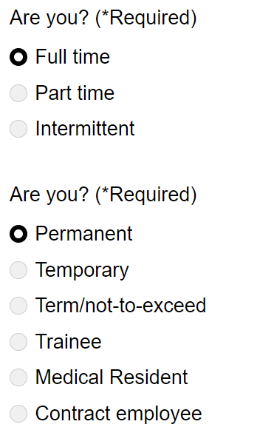

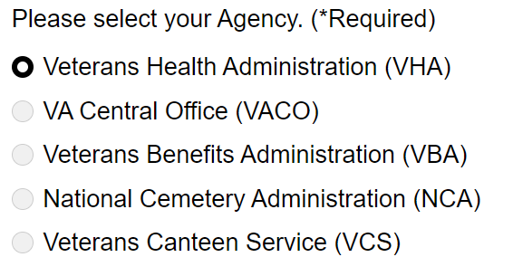

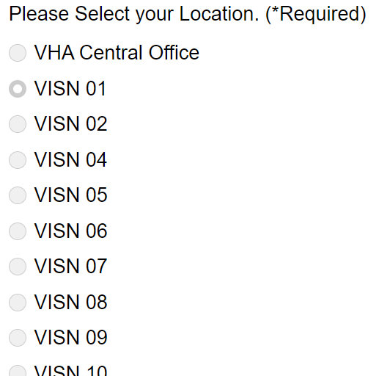 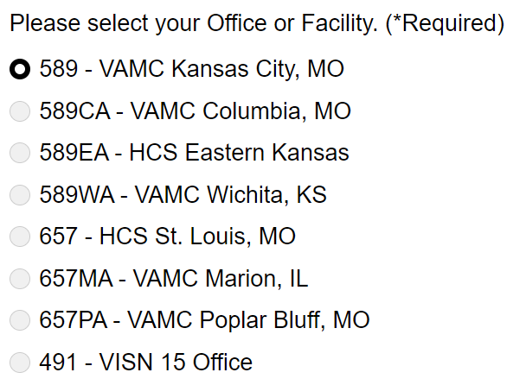

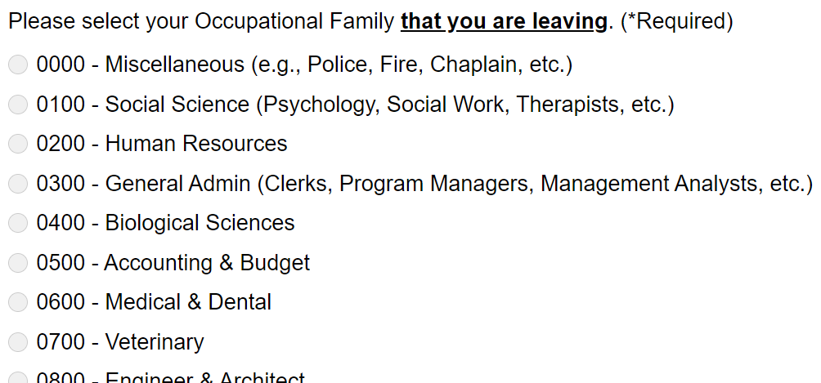

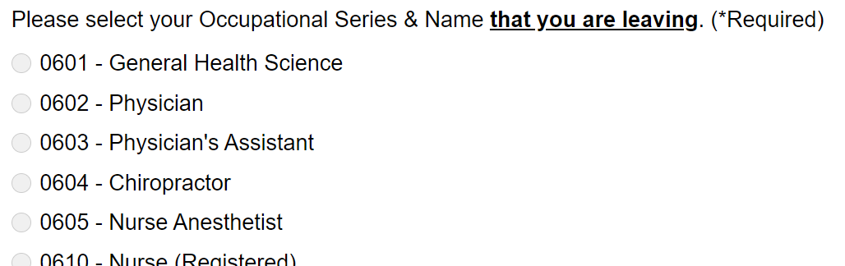

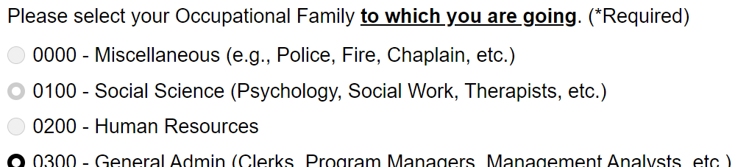

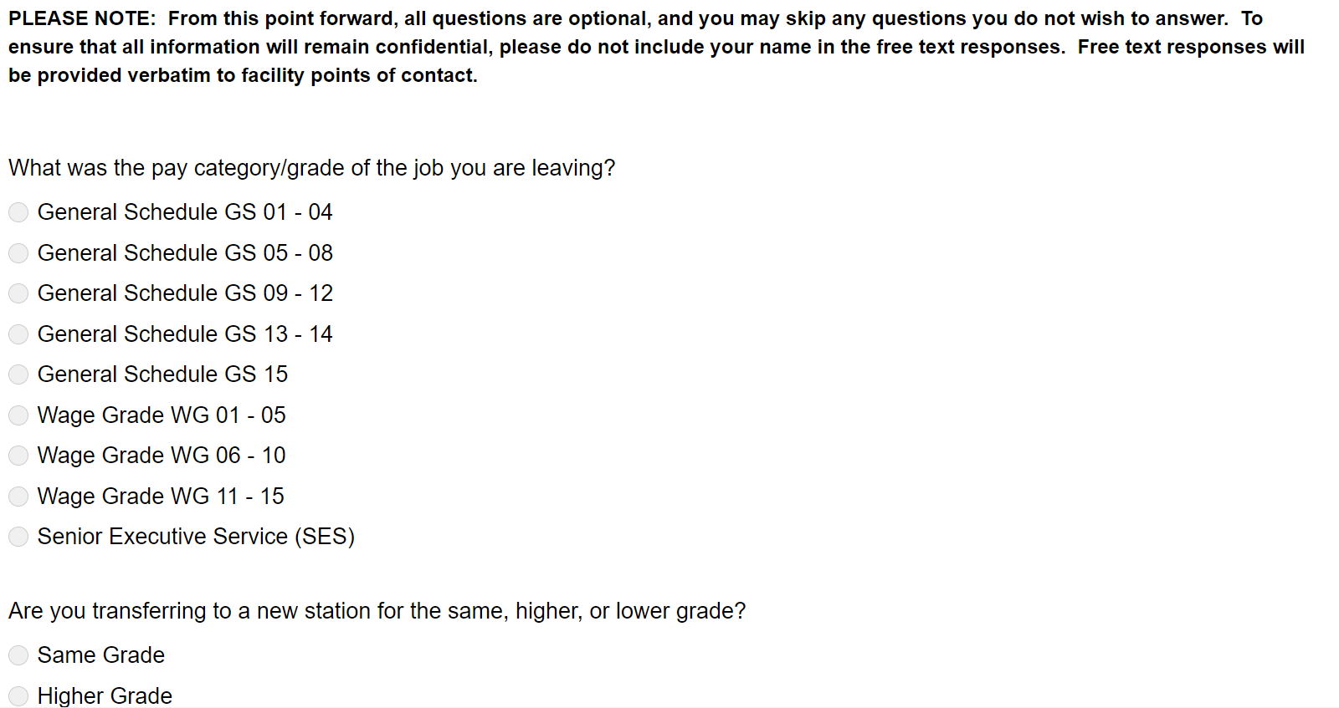

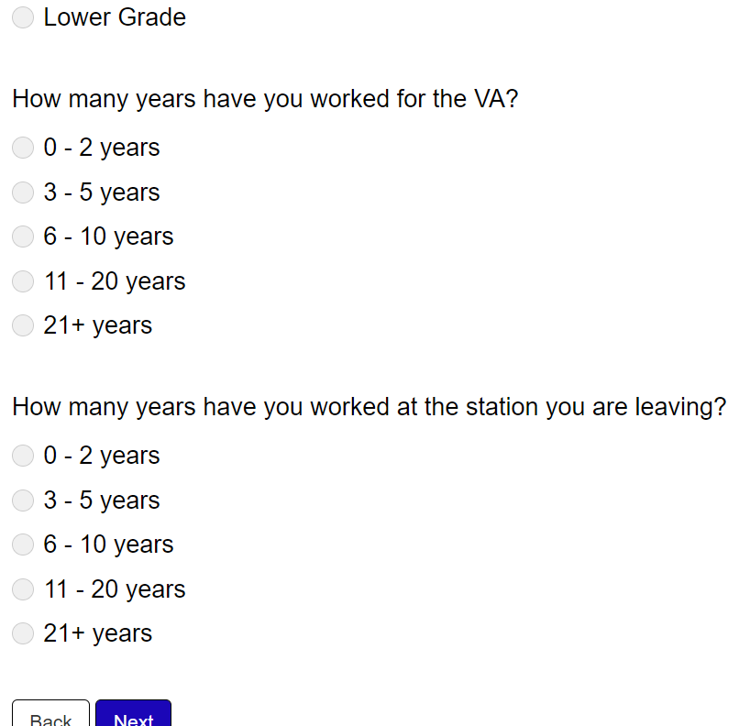

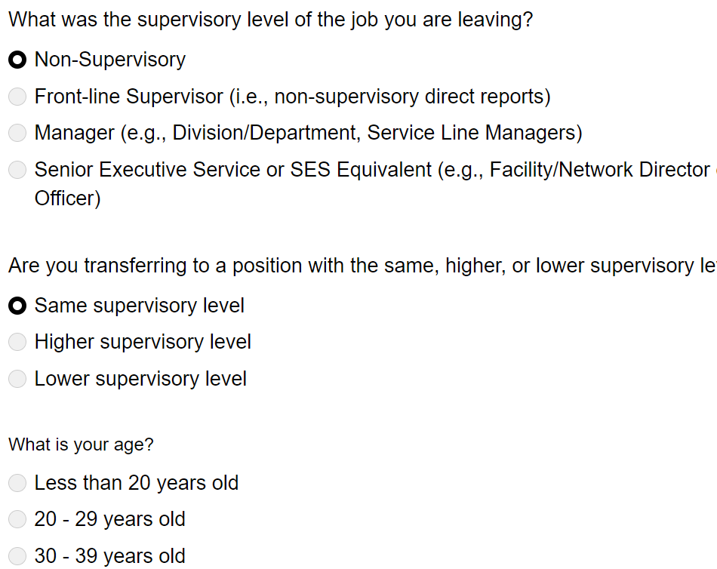

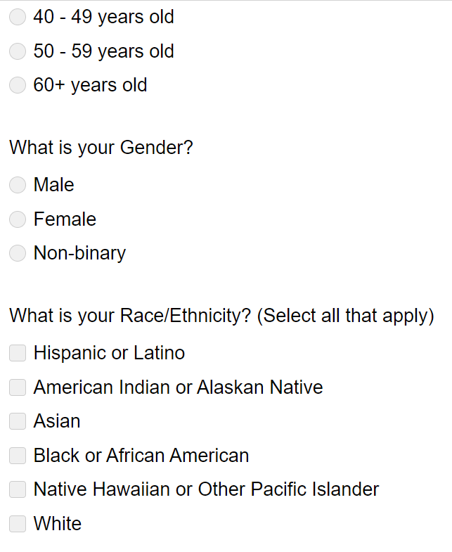

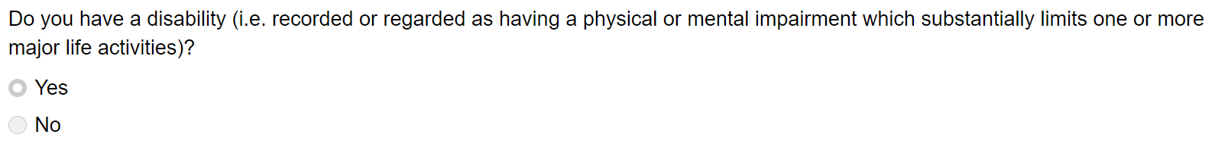

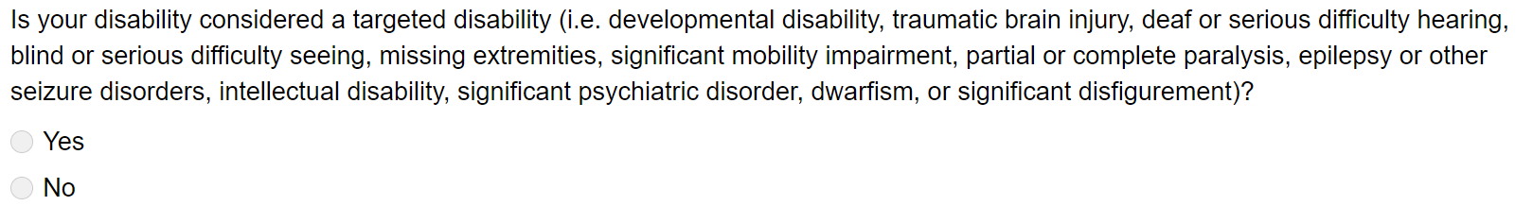

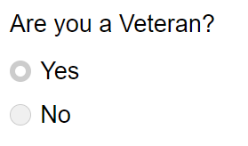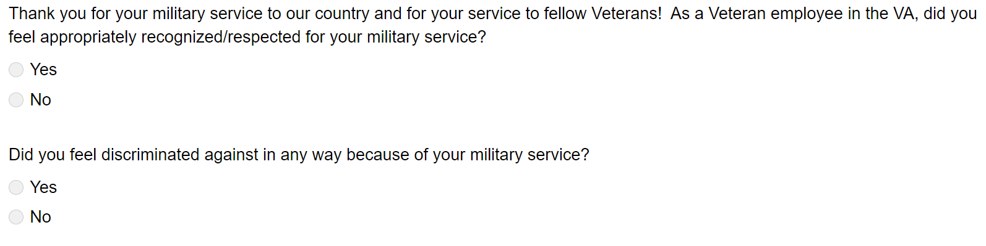

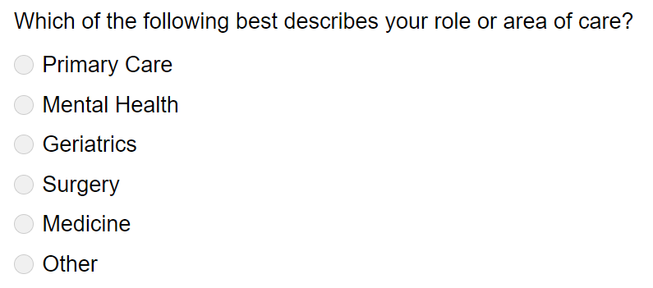

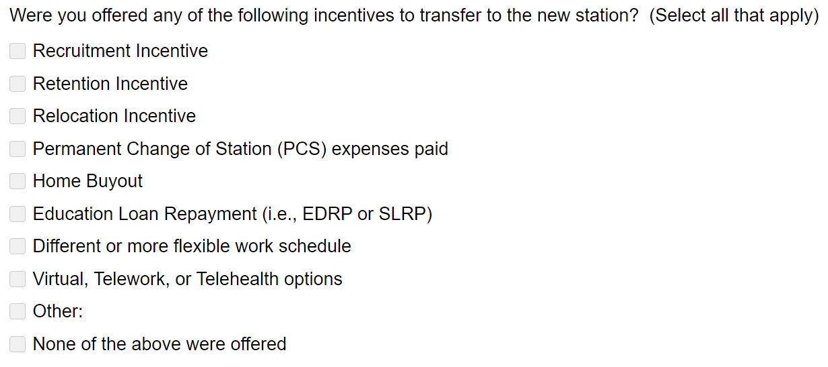

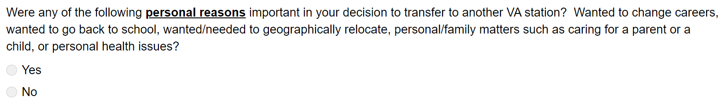

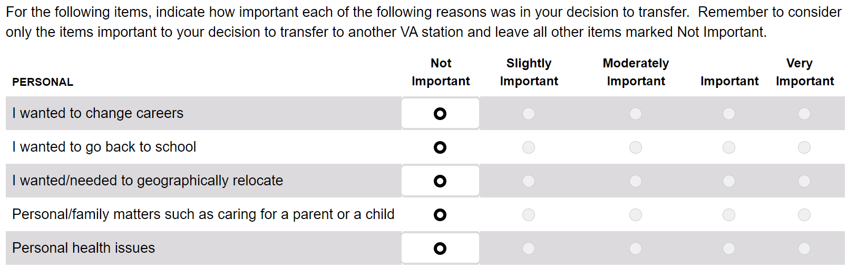

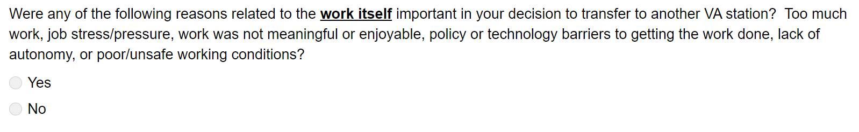

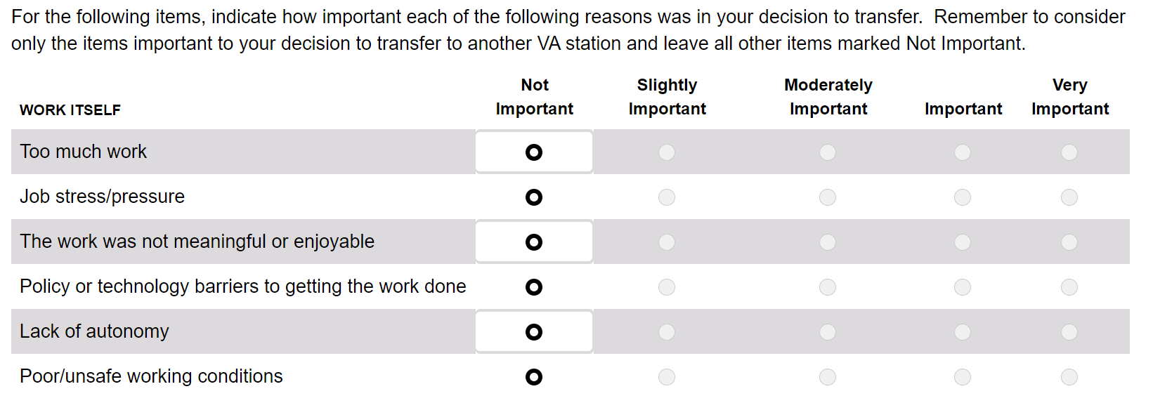

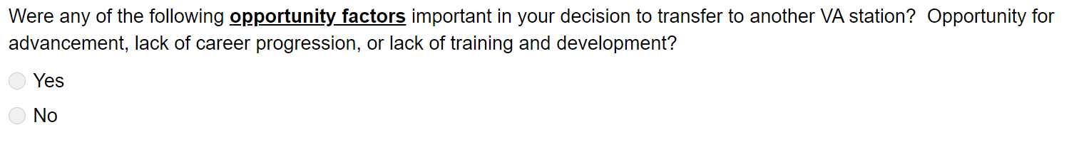

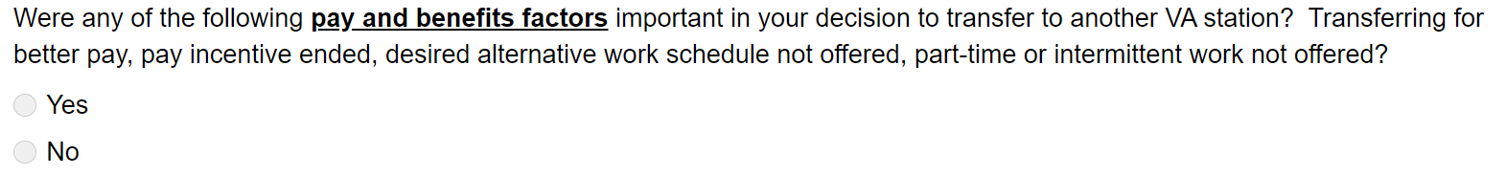

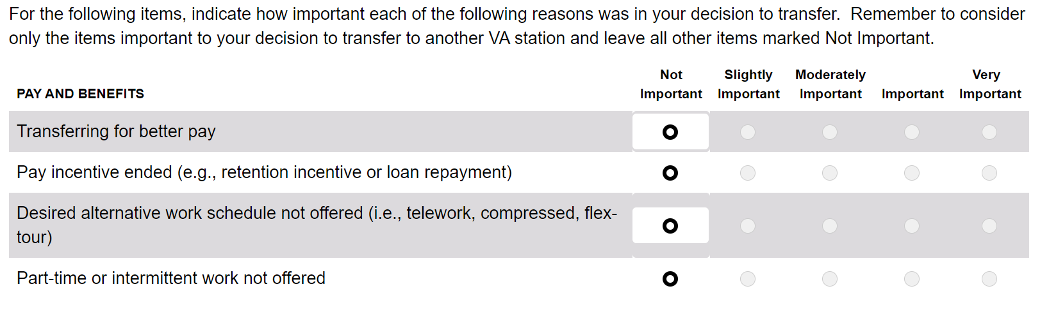

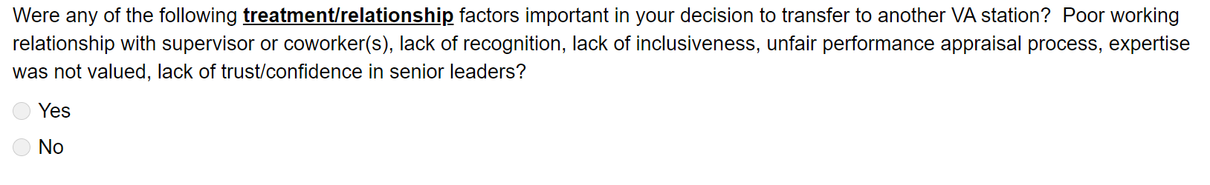

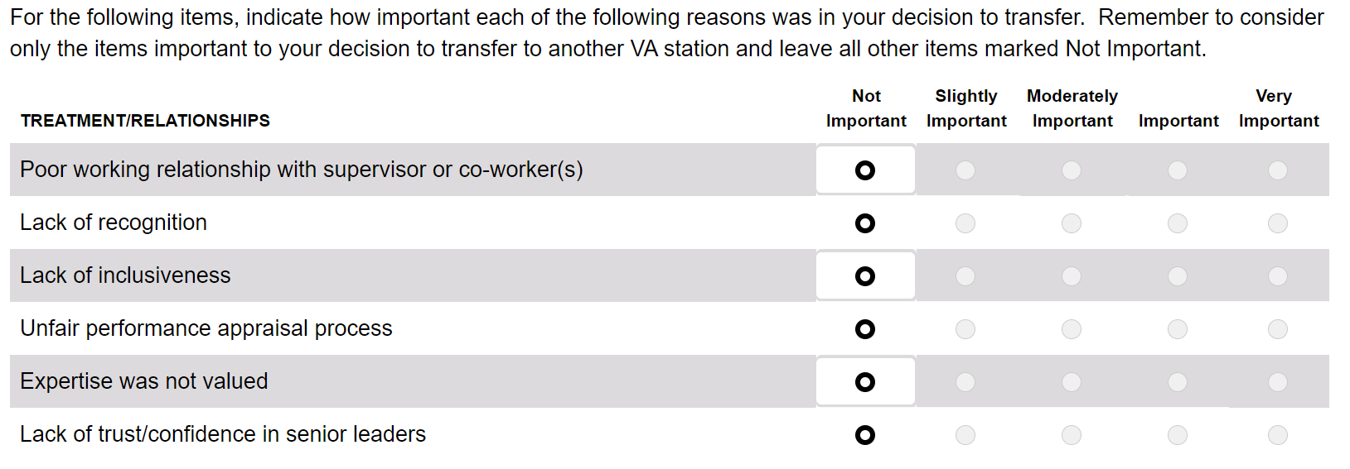

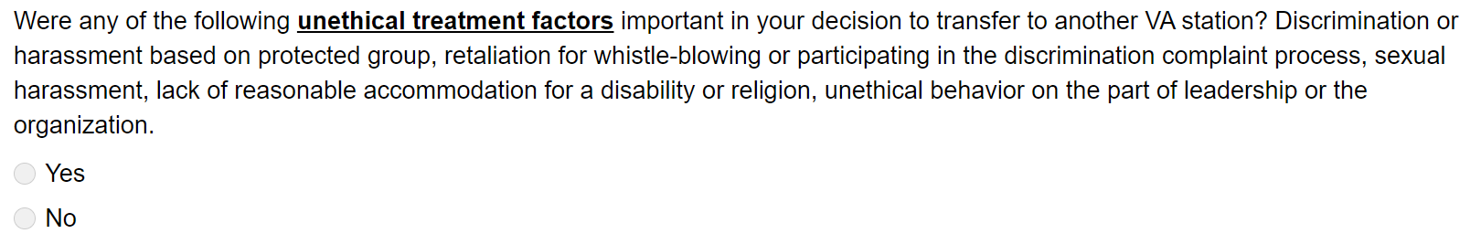

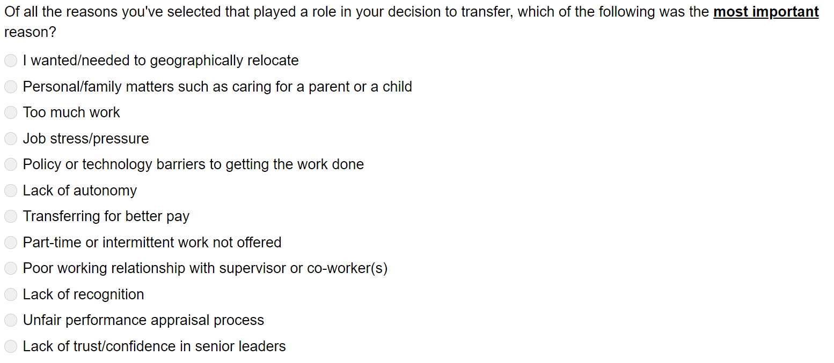

*** So, it looks like the survey asks: Any of the following… If YES, then it breaks it down to how much for each, and then the **most important** reason. If I answered NO, then the weighted scale doesn’t show up. (i.e. unethical treatment factors was a NO, so didn’t have to rank the reasons)***

