Save the Date

Next Lunch and Learn

9/19/2023

Topic: Weingarten Rights

Presenter: Video

Handouts: yes

Food: gourmet box lunches

Location: Hall of Heroes 10AM to 1PM

CBOCs will have food ordered by the cboc mobilization captain. If you need the name of your captain, please call the office, and ask. 816-922-2040

**All non-supervisor union members are welcome to the official meeting:**

All CBOCs will have food available between 11am and 1pm on 9/19

This will be provided by your captain.

If your permanent work location is at **9th and Locust on 9/19**, please reach out to [910afge@910afge.org](mailto:910afge@910afge.org)

2nd and 3rd shift will be provided lunch/dinner boxes between 2pm and 11pm on 9/19/2023 and also a breakfast option from 6am to 9am on 9/20/23. Room M11-244

** note if you are off work, you have the option to drive in for your meal.

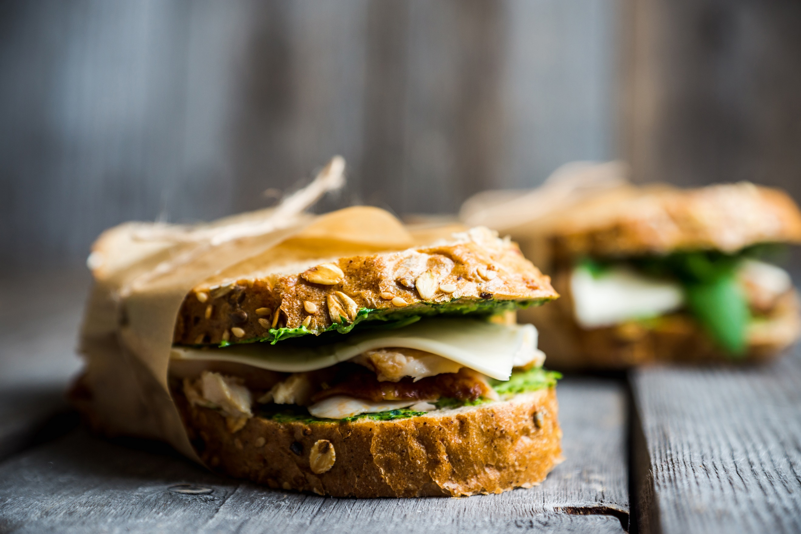







**AFGE Local 910 Official Meeting**

Notice sent 8/14/2023

**Meeting to be held 9/19/23**

Official meeting will be held in room M11-244

at 430pm Location: Union office.

Official meeting agenda will be:

* Roll Call
* Financial Report
* Past concerns
* Info on election

Election committee will speak

* Report of committees
* Situational awareness